LEVERS

A lever is a rigid bar and all levers have the following parts.

• Fulcrum - fixed point about which the lever turns.
• Effort (force) - force applied to the lever.
• Effort arm - distance from the fulcrum to the point where the effort is applied.
• Load (force) - force moving the load.
• Load arm - distance from the fulcrum to the position of the load.

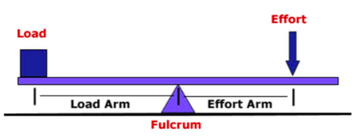

There are 3 classes of levers.

First Class

• Effort arm is longer than the load arm.
• Has a force advantage but distance disadvantage.

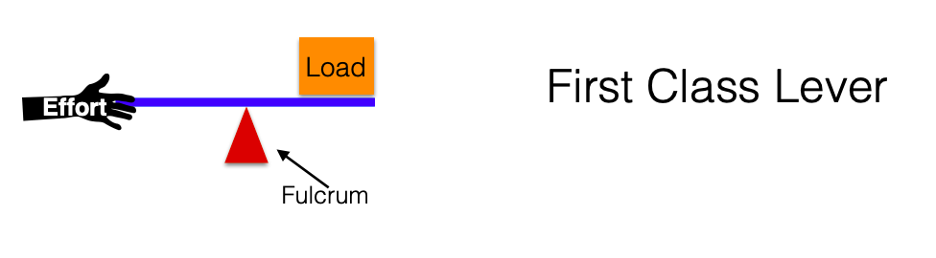
Example: crowbar
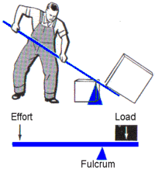

Second Class

• Effort arm is longer than the load arm.
• Lad and effort are on the same side from the fulcrum.
• Has a force advantage but distance disadvantage.

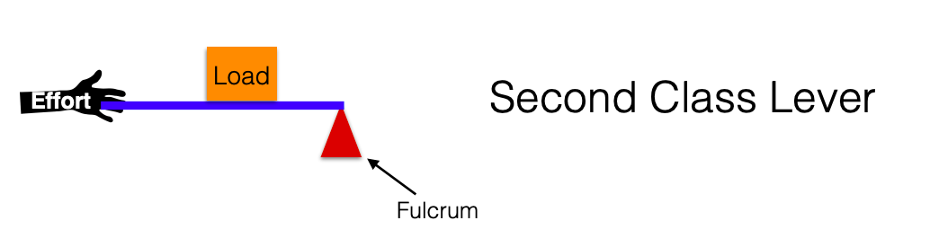
Example: wheelbarrow
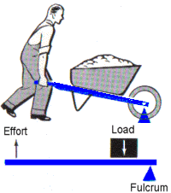

Third Class

• Effort arm is shorter than the load arm.
• Has a force advantage but distance disadvantage.

Example: fishing rod 